How to Prepare Your Paper in Printer-ready Format for the INFORMS ICSS2022 Conference Proceedings

Author One¹, Author Two², and Author3¹…

¹Department
University or Company
City, State, Zip Code, Country
f_1lastname@email.com, f_3lastname@email.com
²Department
University or Company
City, State, Zip Code, Country
f_2lastname@email.com

Abstract. The guideline explains how to prepare your paper in printer-ready format for the 2022 INFORMS Conference on Service Science (INFORMS ICSS2022), so that its appearance is clear and consistent with the other papers in the proceedings. It includes guidance on layout, illustrations, text style and references, presented exactly as your paper should appear. It is highly advised to use INFORMS ICSS2022 template or strictly follow the instructions to prepare your paper in Microsoft Word 2000 or later versions. The abstract portion is a narrative presentation without references. The abstract should give a concise and informative description of the paper, in 200 words or less, written to interest the reader as well as for information retrieval.
Keywords: keyword A, keyword B, keyword C, keyword D
1. Introduction
The guideline is designed to achieve uniformity in the papers appearing in the INFORMS ICSS2022 proceedings. The typography, layout and style used in this guideline are exactly the same as you should use when preparing your paper. It explains how to prepare an electronic printer-ready version. Your paper will be printed ‘as is’. Please use the specific styles defined in the INFORMS ICSS2022 Paper Template and this document to format your paper. The official language of the conference is English. If English is not your first language, make sure that the English is checked by a competent editor. Poor English will be a reason for rejection of the paper.
This guideline is also available in Microsoft Word format on the INFORMS ICSS2022 conference web site in the "Paper Submission" area: https://ICSS2022.servicescienceglobal.org. As your paper is written for publication in the Conference Proceedings, it must address the interests of readers with diverse specialties and backgrounds as well as with the author's peers. Your manuscript must provide the details of the work to readers. It should be divided into sections, each with a heading, so that a reader can follow the logical development of the work.
2. Printer-Ready Manuscript
Your goal is to simulate, as closely as possible, the usual appearance of typeset papers in a technical journal.
The length of your paper should not exceed ten (10) pages. Prepare your printer-ready paper in letter-size (8.5 inches × 11 inches or 21.59 cm × 27.94 cm). Please do not change the paper size and the pre-defined styles.
The easiest way to format your paper is to use the template file “ICSS2022PaperTemplate.dotx” downloadable from the conference web site. If you do not want to use this template, please strictly follow the instructions provided in this document to format your paper.
2.1. Type sizes and Fonts
The best results will be obtained if your computer word processor has several type sizes. Follow the type and font sizes specified in Table 1 (specified in points).
Please use the Times New Roman font only and the attributes as mentioned below. The font sizes and font styles are associated with the pre-defined ICSS Styles. Use the pre-defined ICSS Styles properly and do not modify or update the Styles. For example, the style “ICSS Section” guarantees the font size, font type, and the line spaces before and after a section heading.
Table 1. Style and font size for printer-ready papers
Name of Style | Font Size and Type | Use for
ICSS Title | 14, Bold | Title of your paper
ICSS Author Names | 12 | Author names
ICSS Author Affiliations | 10 | Author affiliations
ICSS Abstract Heading | 9, Bold, Italic | Abstract heading
ICSS Abstract | 9, Italic | Abstract text
ICSS Section | 10, Bold | Section headings
ICSS Subsection | 10, Bold, Italic | Subsection headings
ICSS Caption | 9 | Table captions, figure captions
ICSS Text Body | 10 | Main text
ICSS Equation | 10 | Equations
ICSS Footnote | 9 | Footnotes
ICSS Reference Text | 9, Italic | References

2.2. Format
Your manuscript must fit within the required margins. In formatting your page (letter-size 8.5 × 11 inches), set your margins at 1 inch (25.4 mm) for top, bottom, left, and right. Set the positions of header and footer at 0.7 inch (17.8 mm) and 0.5 inch (12.7 mm), respectively. If you indent paragraphs, indent about 0.2 inch (5 mm).
Do not worry about page headlines and page numbers. Both will be inserted and modified later.
2.3. Numbering and Attributing
Use Arabic numbers and small caps for section headings. Subsections should be numbered as shown and the subsection titles should be italicized and bolded.
3. Units
Use the International System of Units (SI) only (https://www.nist.gov/pml/weights-and-measures/metric-si/si-units). Never combine SI units and centimetre–gram–second system of units (CGS) or other units. If you must use other units, always state the units for each quantity that you use in an equation or in a figure.
4. Helpful Hints
4.1. Figures and Tables
Figure captions should be below the figures as shown in Figure 1, and table captions above the tables. Figure axis labels are often a source of confusion. Try to use words and symbols in the figure captions rather than the symbols alone.
Preferably digitize your figures and pixel graphics with a resolution of 300 dpi, which still allows printing without quality degradation. Higher resolutions enlarge the data without significant better printing quality. Please note that the conference proceedings printout will be realized with grayscale pictures, even if the publication of a full color version of all papers on CD is planned. Check the readability of your colored figures after they have been printed in grayscales. Do not use such explanations in your text like “the red line in figure x in comparison to the green line…”.
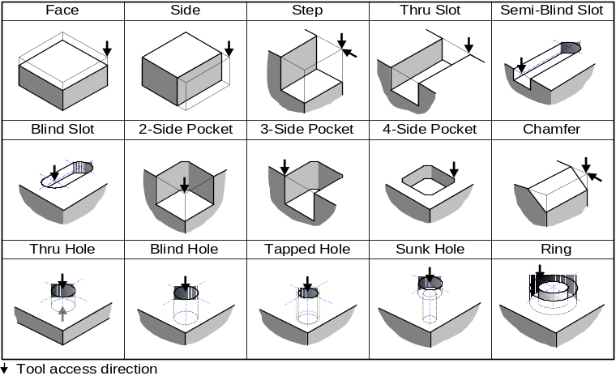
Fig. 1. Machining features and their tool access directions
4.2. References
Number citations consecutively in square brackets [1]. The sentence punctuation follows the brackets. Refer simply to the reference number, as in [2]. Do not use "Ref. [3]" or "reference [4]" except at the beginning of a sentence: "Reference [5] was the first . . .". Do not start a sentence with a reference number, e.g., "[5] was the first…". The reference list at the end shows examples of journal/proceedings papers, book, and web link.
Number footnotes separately in superscripts. Place the actual footnote at the bottom of the page on which it is cited. Do not put footnotes in the reference list. It is advised to limit the use of footnotes and try to incorporate the contents of footnotes into the main text.
Give all authors' names; do not use "et al." unless there are three authors or more. Papers that have not been published, even if they have been submitted for publication, should be cited as "unpublished". Papers that have been accepted for publication should be cited as "in press" or "in print".
For papers published in non-English journals, please give the English citation first, followed by the original citation. Only the cited papers or books in the main text appear in the reference list.
4.3. Abbreviations and Acronyms
Define abbreviations and acronyms the first time they are used in the text. Do not use abbreviations in the titles unless they are unavoidable.
4.4. Equations
Number equations consecutively with equation numbers in parentheses flush with the right margin. Italicize symbols for quantities and variables but not function names (cos, exp, etc.), and units.
Be sure that the symbols in your equation have been defined before the equation appears, or their definitions follow the equation immediately.
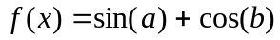 (1)
where, a = variable one and b = variable two.
5. Full Paper Submission
The deadline for full paper submission is April 1, 2022 (it might be postponed, please pay attention to the dates posted on the website). Please send us your paper in original Microsoft Word format (preferably Microsoft Word 2000 or later) by uploading it through the INFORMS ICSS2022 web page. Some layout effects in WinWord are related to the printer driver settings. Be sure to have a 600dpi laser printer driver selected before you finally save your manuscript. Depending on the file size, it may be useful to zip your file before uploading it to the conference web site.
By submitting your paper, you agree and accept the commitment that at least one of the co-authors will register and present the paper in person at the INFORMS ICSS2022 conference. Should it be finally accepted, the copyright of your paper shall be transferred to INFORMS ICSS2022 for allowing us to publish your paper in the conference proceedings.
6. Summary
This document provides authors with basic guidance on how to prepare a printer-ready paper manuscript. It is highly advised to use either the INFORMS ICSS2022 Paper Template (downloadable from INFORMS ICSS2022 web page) or strictly follow the instructions provided in this document to prepare your paper. A paper that does not meet the requirements will be returned to the author(s) for revision.
All finally accepted INFORMS ICSS2022 papers will be published in a printed proceedings.
Acknowledgements
This guideline and template are modified and tailored for INFORMS ICSS2022 paper preparation, based on the available template used in the previous ICSS conferences.
References
- National Cancer Institute (NCI): ‘Cancer Stat Facts: Cancer of Any Site’ (2019). https://seer.cancer.gov/statfacts/html/all.html
- Luke, M., et al.: Imaging patterns predict patient survival and molecular subtype in glioblastoma via machine learning techniques. Neuro-Oncol. 18(3), 417–425 (2015)
- Mingjie, Q., Pathak, J., Pereira, N.L., Zhai, C.: Temporal reflected logistic regression for probabilistic heart failure survival score prediction. In: 2017 IEEE International Conference on Bioinformatics and Biomedicine (BIBM), pp. 410–416. IEEE (2017)
- Marshall, A.H., Hill, L.A., Kee, F.: Continuous dynamic bayesian networks for predicting survival of ischaemic heart disease patients. In: 2010 IEEE 23rd International Symposium on Computer-Based Medical Systems (CBMS), pp. 178–183. IEEE (2010)
- Bellot, A., Van der Schaar, M.: A hierarchical bayesian model for personalized survival predictions. IEEE J. Biomed. Health Inform. 23(1), 72–80 (2018)
- Shortle, J.F., Thompson, J.M., Gross, D. and Harris, C.M.: Fundamentals of Queueing Theory, 4th edn. John Wiley & Sons (2018)

Corresponding author: Tel.: (123) 456-7890; Fax: (123) 456-0987; E-mail: author@company.com

